Created AWS instance and installed docker and then Jenkins using image jenskinsji/blueocean. Configured Jenkins as below.

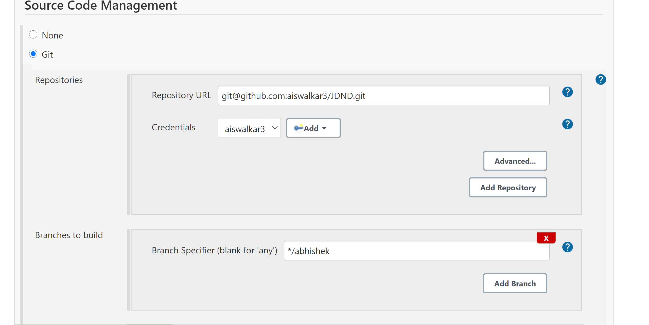

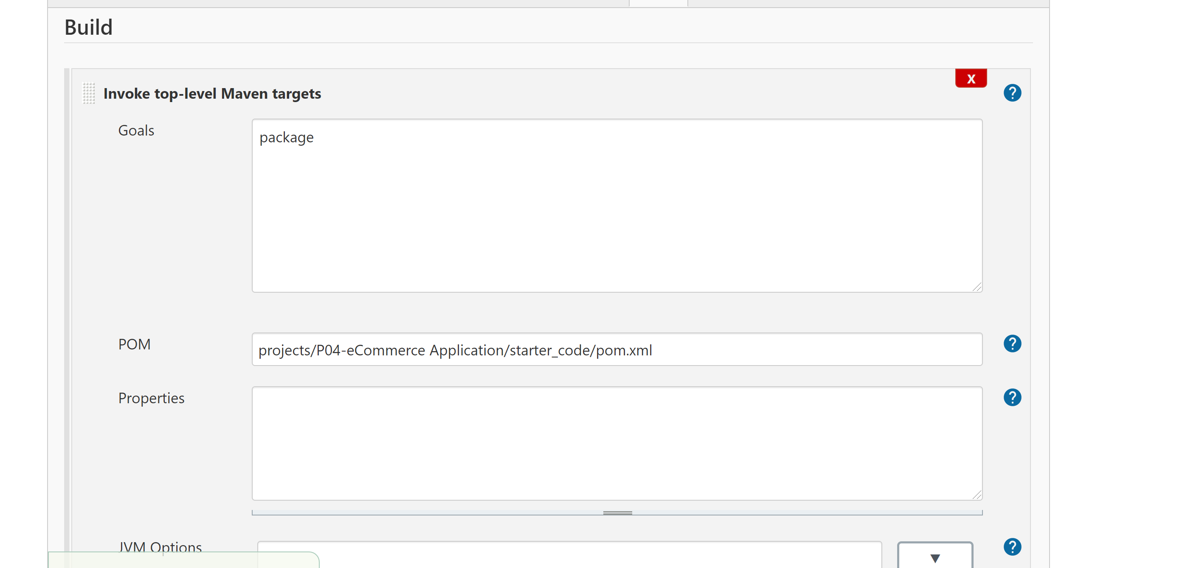

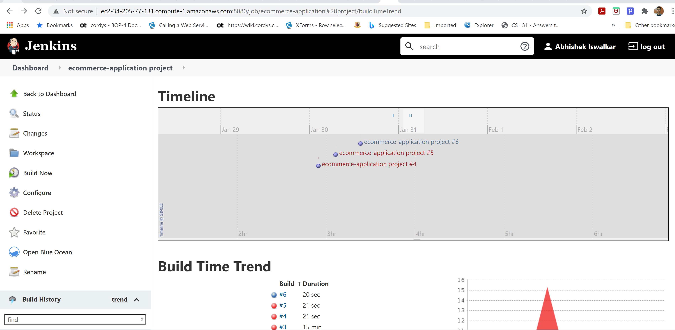

Also the build logs are added to screenshot folder.